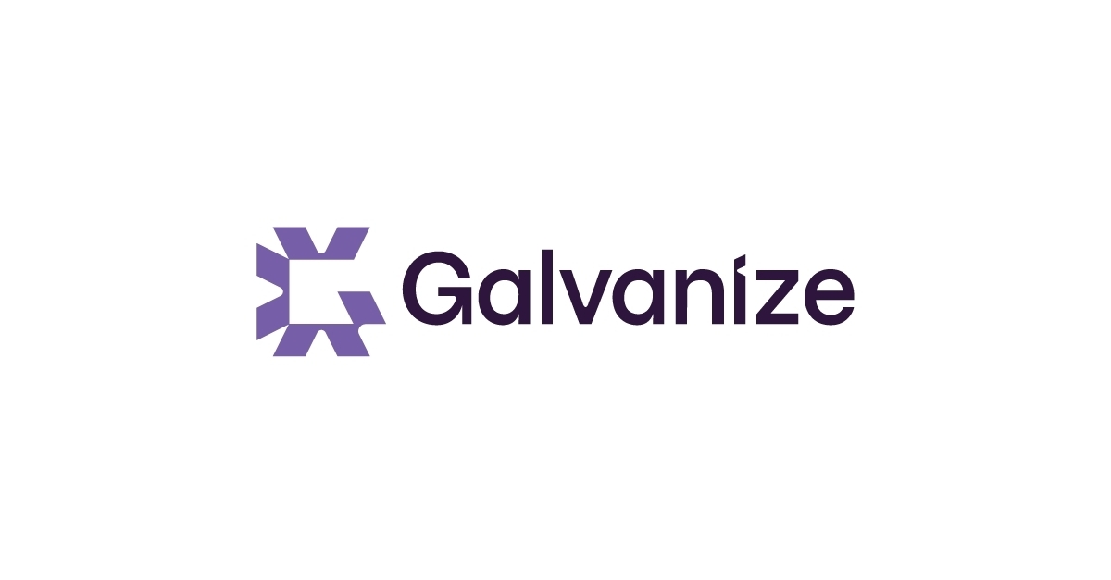**Content Hub**

Design Document

March 30th , 2020

Version 1.0

Team Galvatron

David Guo 57734162

Pengwei Zhou 73569758

Peter Han 14912166

Tony Kong 47078150

Tyler Nee 22705157

Vickie Yen 13358156

Yuting Wen 44625168

Revision History

|  |  |  |  |  |
| --- | --- | --- | --- | --- |
| **Date** | **Version** | **Status** | **Prepared by** | **Comments** |
| Jan 27, 2020 | 0.1 | Start | Team Galvatron | Initial design document submission |
| Mar 30, 2020 | 1.0 | Final submission | Team Galvatron | Final design document submission |

## Stakeholder Sign-off List

|  |  |  |  |
| --- | --- | --- | --- |
| **Role** | **Name** | **Signature** | **Date** |
| Project Sponsor | Peter Smith |  |  |

## Introduction

## Overview

The product will consist of a website that consolidates content and points to the content’s original location from other websites and repositories. The site will have admins from contributing organizations monitoring content published to the site via an admin approval system. The main interface of the website will contain a portal to access linked articles. Any individual will be able to create an account and submit content to the site subject to admin approval.

## Goals

* The scope of the Content Hub is to aggregate user submitted blog posts and blog streams on a single platform. More specifically:
  + Users can submit posts and blog streams.
  + Users can search and filter posts.
  + Users can view posts via an RSS feed.
  + Users can receive notifications of newly published posts.
  + Approvers can approve user submitted posts.
  + Admins can add other admins, add/remove approvers, add blog categories,
  + A scheduler runs to scan approved blogs for content to publish and send emails to subscribed users.
* Multi-browser support (Chrome, Microsoft Edge, Safari, Firefox)

## Assumptions

* There is a maximum of 30 approvers
* Maximum articles is 5000

Programming Environment

**Languages:** Javascript ES9

**Libraries/Frameworks:** React 16.13.1, Express 4.17, Passport 0.4.1, Material-UI 4.9.8, Sequelize 5.25.5, cron 1.8.2

**Tools:** Babel 7.9.0, npm 6.13.4, Swagger

**Database:** MySQL Community Server 8.0.19

**Environment:** Node.js 12.16.1

**Operating System:** Ubuntu 18.04 LTS

**IDE**: Visual Studio Code 1.43

**Source control:** GitLab

Production and Test Environments

Our production environment will be deployed on a free tier Amazon EC2 t2.micro instance. We will have scripts that will be run to pull the latest code and rebuild the environment.

Our test environment will be the same as our production environment as we do not have the resources to deploy another Amazon EC2 instance. This environment will be used to run manual tests, while our automated tests will be run locally.

Software Architecture

## 

## Client side

We will be using React along with Material-UI for our UI. We will be having multiple pages that will be built up from multiple components.

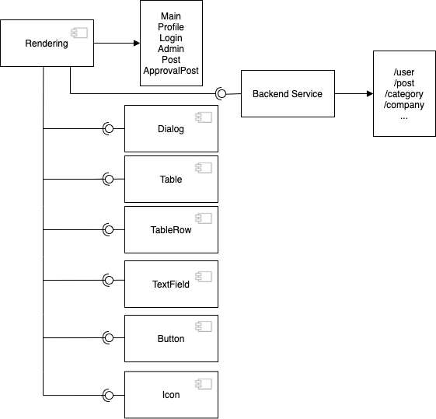

## Server side

**3 Layer Architecture Model**

On the server side we will be separating our logic with a 3 Layer Architecture model. We will be separating our routing logic into a controller layer, our business logic into our service layer and our database access into our data access layer.

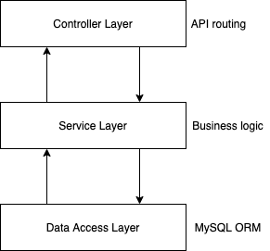

**UML Diagram**

Here’s a UML diagram describing our planned modules and dependencies. We will be using Express for our routing and Passport for our authentication. Our data will be fetched using Sequelize as our MySQL ORM. To look at the diagram in more detail: <https://drive.google.com/file/d/1XdlQfMoRCmLgVX_1BFeMPJebkF_tY1I6/view?usp=sharing>

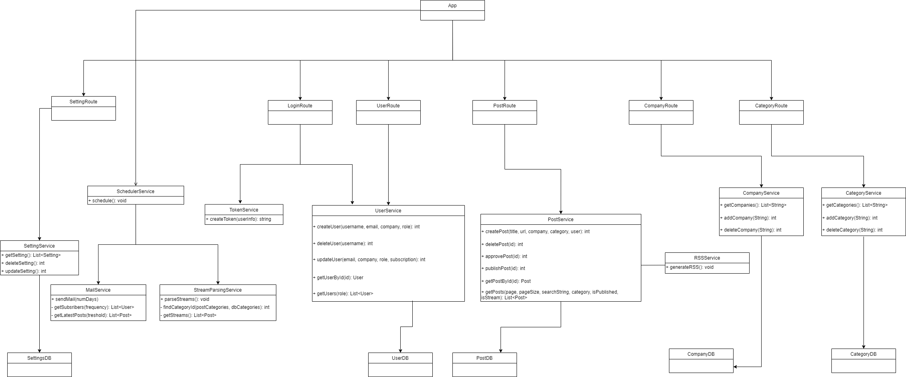

## 

## Authentication

We will be using Google OAuth2.0 for our authentication workflow. After going through our authentication workflow we will be managing our user session using cookies. The benefit of cookie authentication is that the user session will be persisted for a certain amount of time, so the user will not have to re-authenticate on every page visit. Our authentication workflow is as follows:

1. **Client**: Goes through OAuth2.0 process and fetches back the google user including google access token. Sends google access token to server.
2. **Server**: Verifies google access token and creates a new user if one doesn’t already exist. Generate a JWT by signing the user id + role. Add to cookies and send to client
3. **Client**: Receives response with user, and cookie is set.

Data Design

## Entity-Relationship Diagram

Our database will have 6 tables. Each table User, Post, Company, Category, and Settings represents an entity and holds information to do with that entity. The Post Approver table holds information regarding the relationship between posts and approvers - who has approved what post. This will allow us to show the names of the approvers who have approved a post.

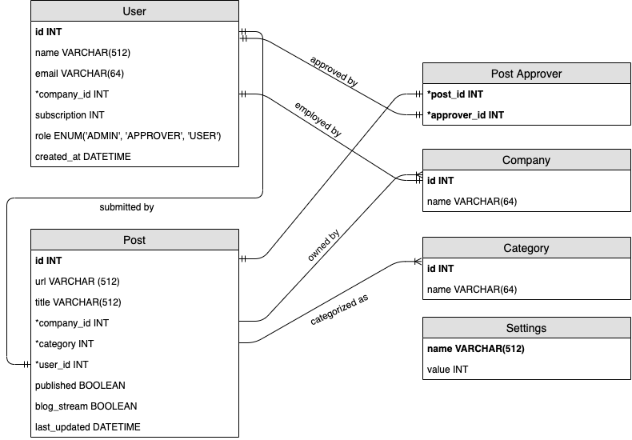

API Design

We have used swagger to create our API documentation. Follow this link for more detailed information: <https://app.swaggerhub.com/apis/vickieyen/content_aggregator/1.0.0-oas3>

We will be creating a RESTful API, that supports create, retrieve, update, and delete operations on each of our database entities as appropriate.

* Most of our endpoints require authentication, in order to be authenticated, the request will need to include a session cookie.
* When retrieving posts, we decided to use **pagination** in order to reduce load times.
  + For instance, in GET /post, two additional parameters are provided, **page** and **pageSize**.
  + These parameters will ensure that only pageSize entries are returned for the corresponding page provided.

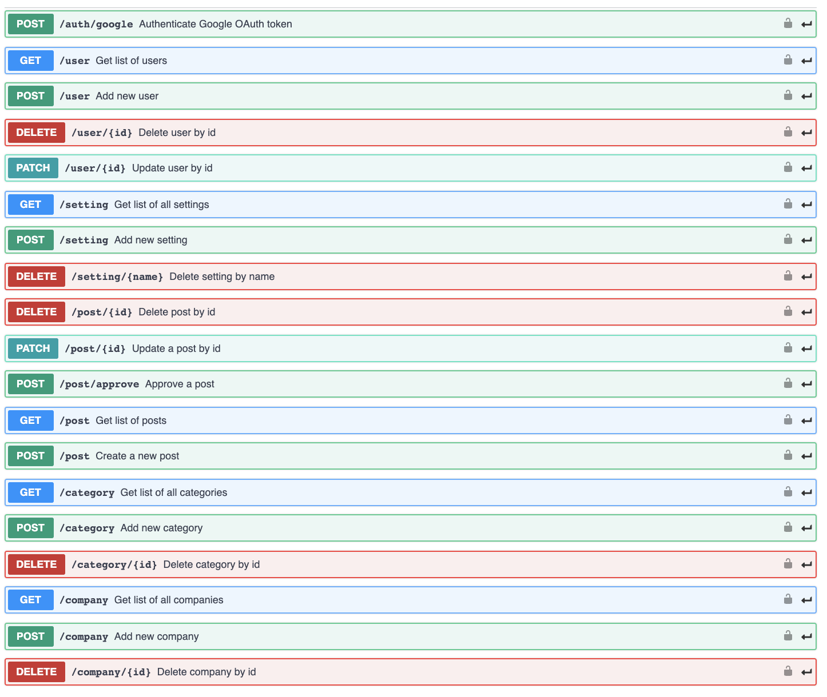

Notable Trade-Offs

* Using **pagination** as opposed to **infinite scroll** may reduce loading time.
  + As mentioned under the API Design Section, we will be using pagination to retrieve posts, as this will speed up home page load time. As there are more and more posts published overtime, using infinite scroll would hinder performance time, thus using pagination is a better choice.
* Having **separate pages for approving unpublished posts** as opposed to **aggregating all posts (unpublished/published) on the same page**
  + We decided to keep unpublished posts and published posts on separate pages, as this was more organized and easier for admins and approvers to approve posts.
* **No access to deleted posts** as opposed to **access to deleted posts** allows us to not keep track of previously deleted posts.
  + We will not keep track of deleted posts, as there is no requirement for admins to be able to access deleted posts. Keeping track of deleted posts will require database changes and more work and we would like to focus on the goals outlined under the Goals Section.

Notable Risks

* Deploying to AWS could prove to be difficult and burdensome, as no team members in the group have experience in this. Therefore, this might take more time than required.
* Security risks with user session management, as no team members know the proper security protocols for properly managing user tokens.

UI Mockups

Our initial UI Mockups include ideas for our login page, user profile page, home page, and admin panel.

Login Page:

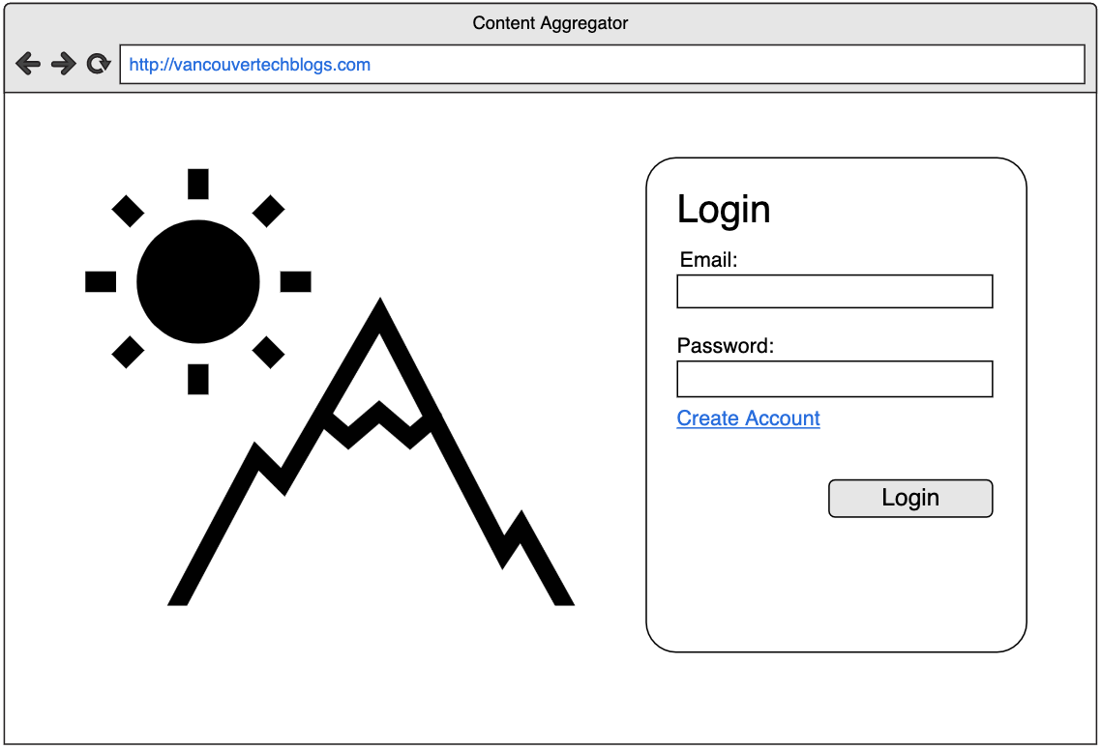

Home Page (User View): 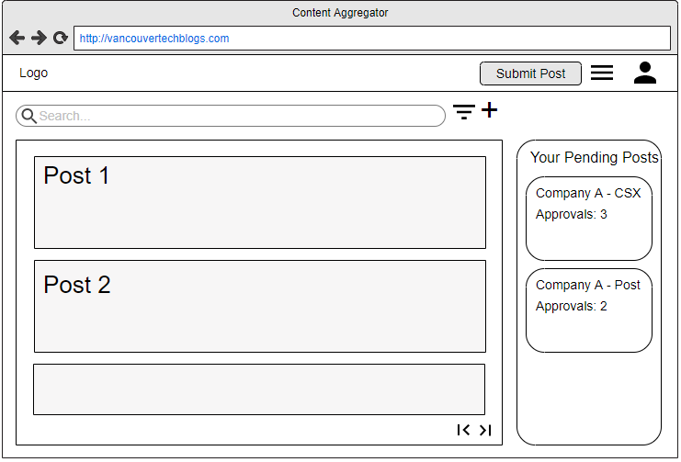

User Profile:

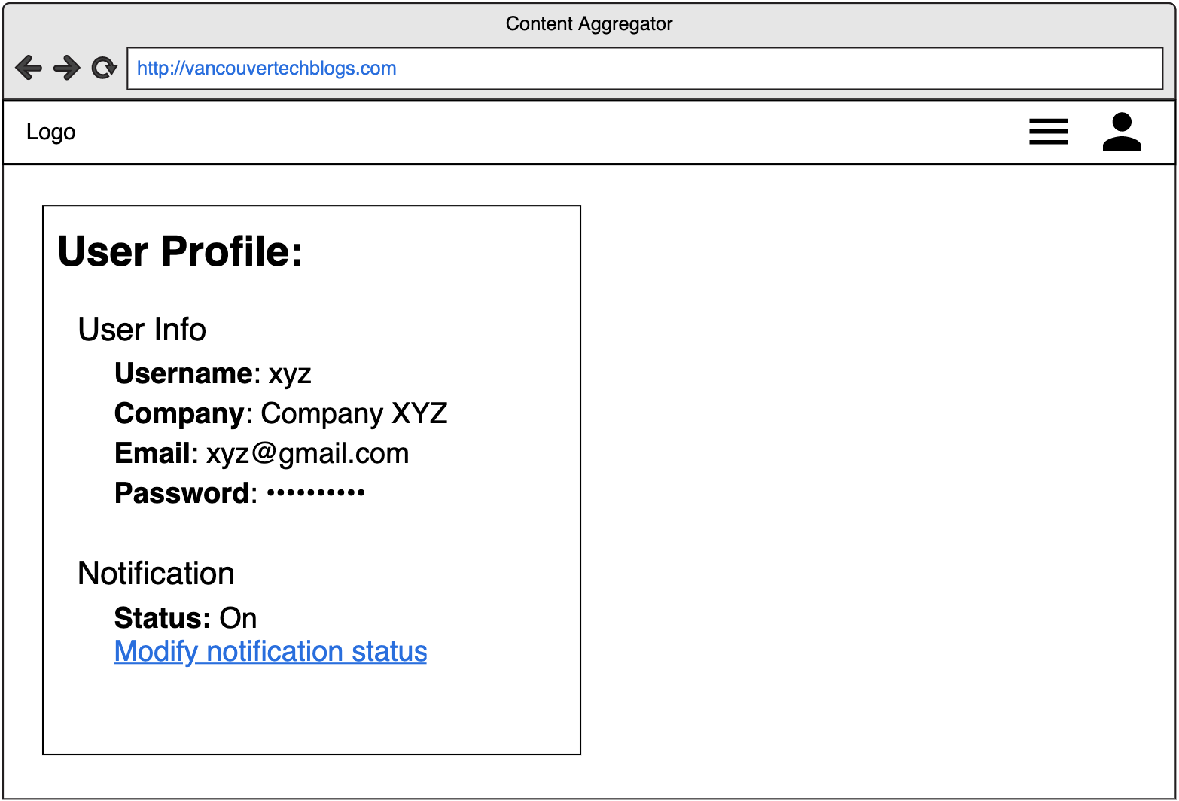

‘Submit Post’ Popup (Post):

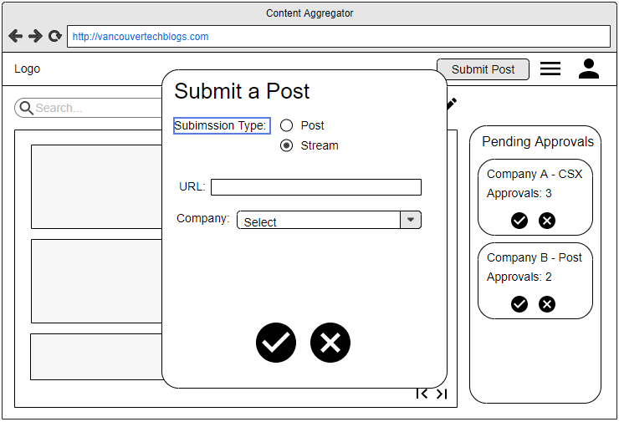

Home Page (Admin View):

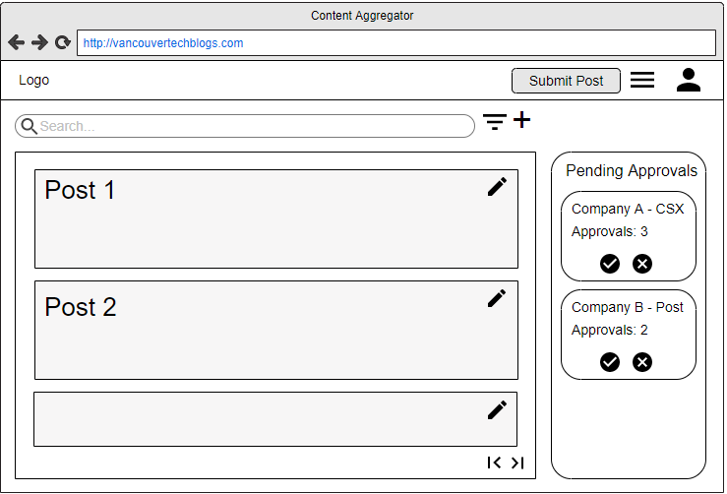

Admin Panel (Blog Stream Tab):

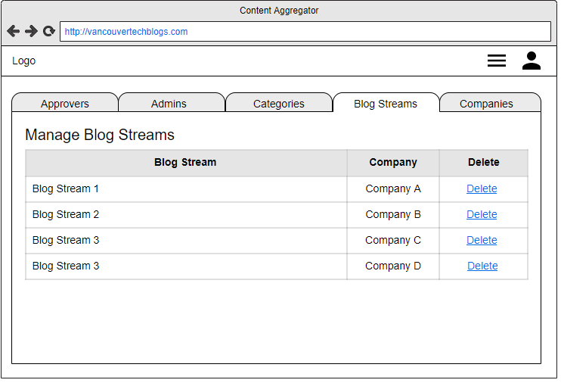

Admin Panel (Approvers Tab):

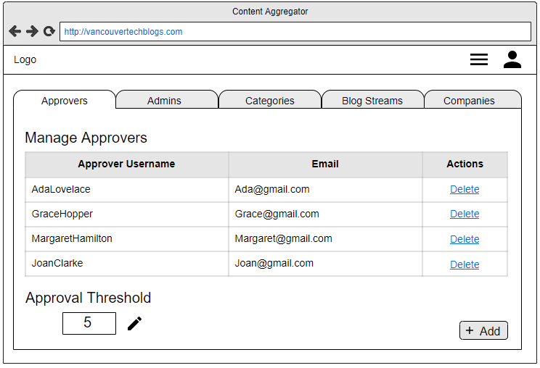

Admin Panel (Admins Tab):

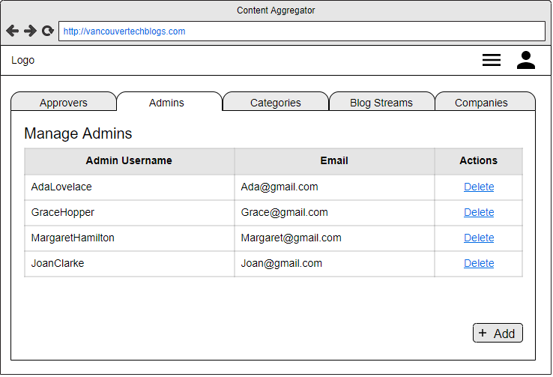

Admin Panel (Categories Tab):

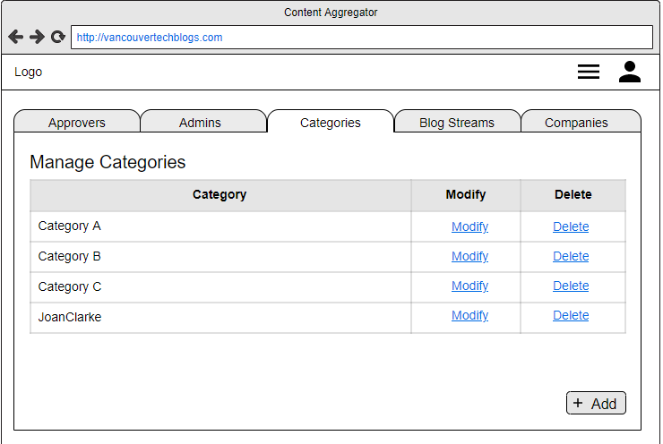

Admin Panel (Companies Tab):

